Module 06 Final Project House Pricing Screenshot Evidence and Discussion
This document brings together the screenshots that the final project requires and gives each one a heading that matches the question it answers. The project predicts house prices in King County from kc_house_data_NaN.csv, 21613 sales with 22 columns, and the ten questions run from data types through cleaning and exploratory analysis to linear regression, a pipeline and two Ridge models. The file name of each image is printed below it.

FinalProject_1. Module 1 Downloading the King County dataset
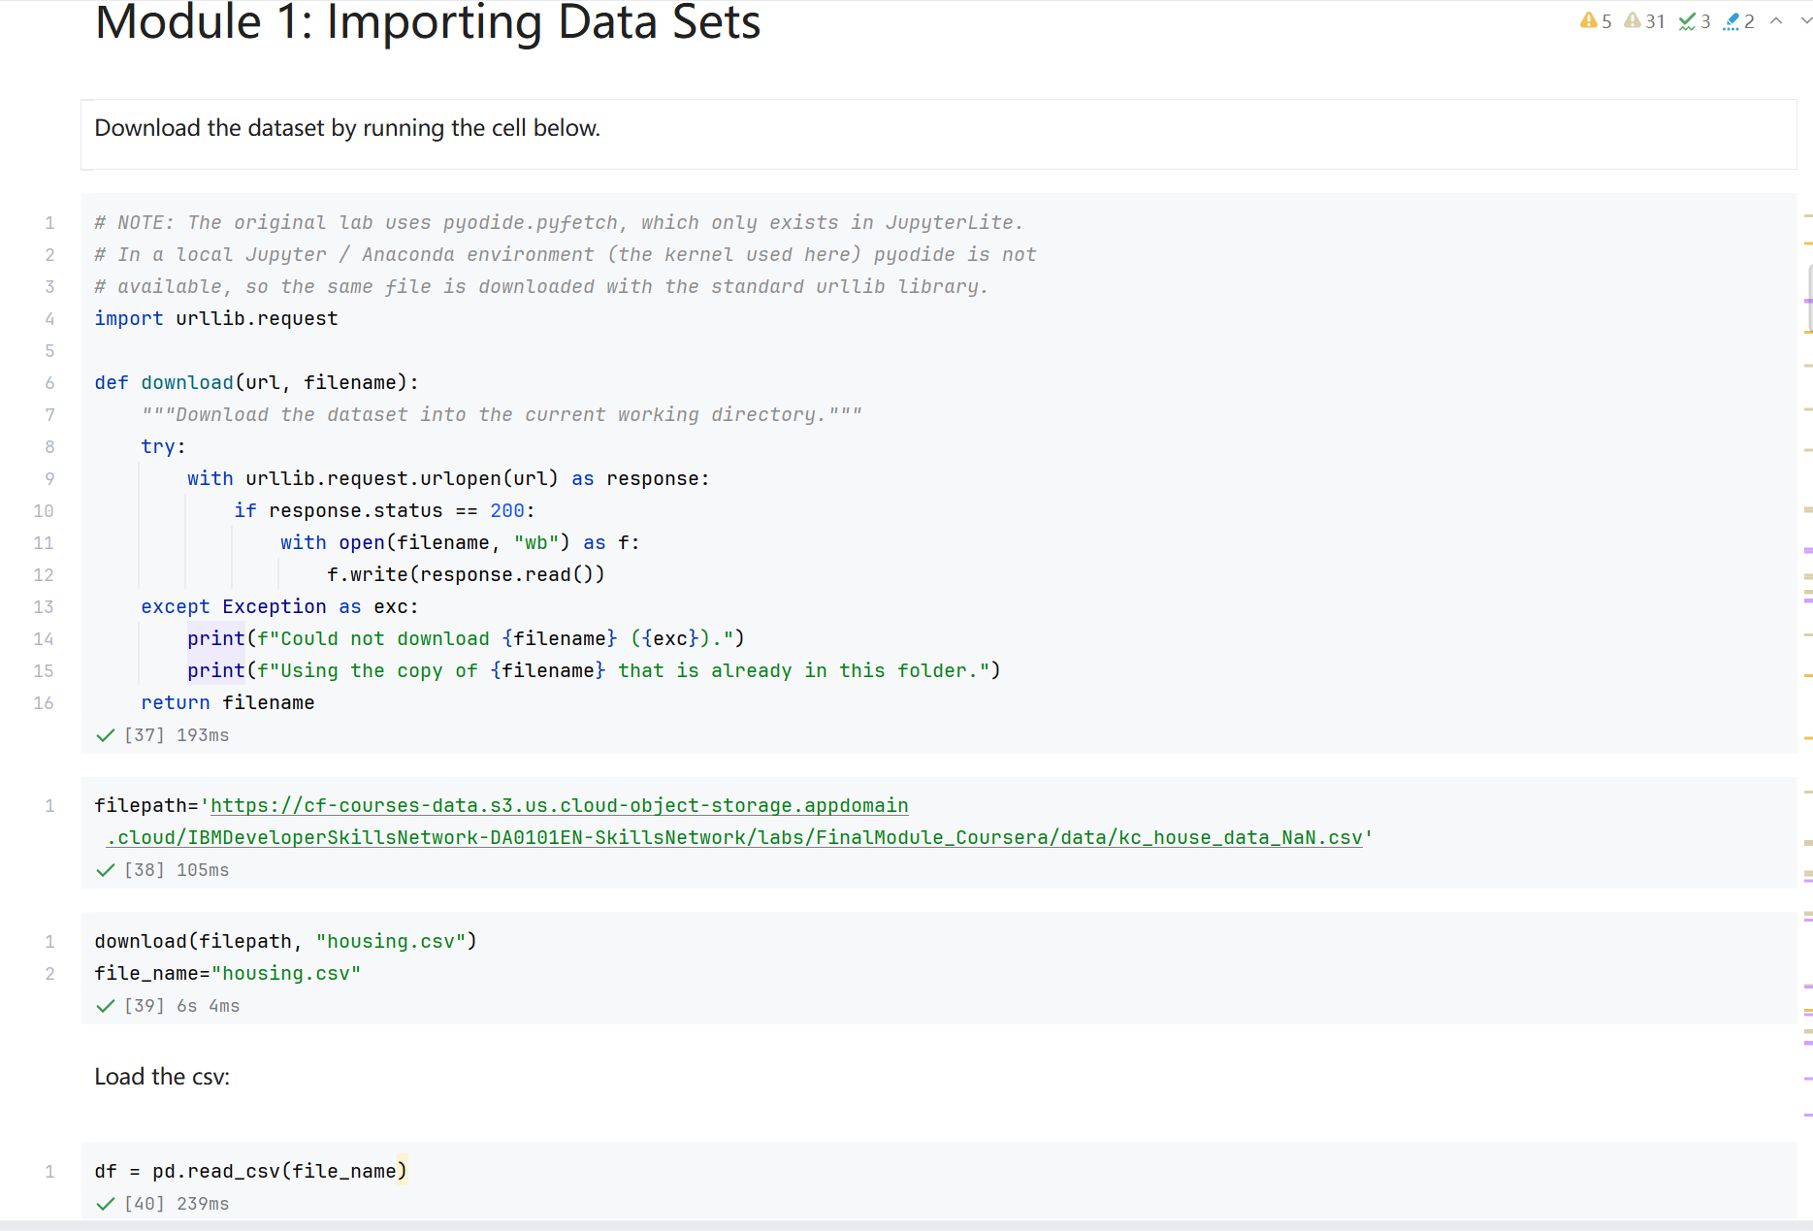
Screenshot file: 01_download_function_urllib.png
(image width 16.4 cm, scale to fit)
The download function fetches kc_house_data_NaN.csv and stores it as housing.csv in the working directory, so the notebook can be re run without downloading the file again.

FinalProject_2. Module 1 Reading the dataset and previewing the first rows
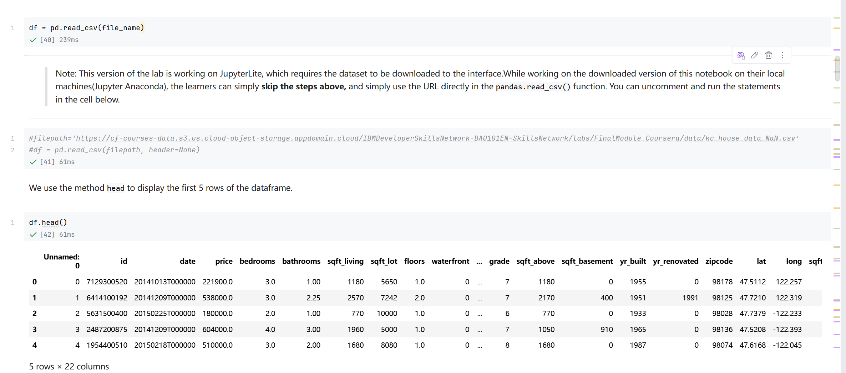
Screenshot file: 02_read_csv_and_df.head.png
(image width 16.4 cm, scale to fit)
df.head() after pd.read_csv shows the structure of the file, including the unnamed index column that is dropped later and the price column that the models predict.

FinalProject_3. Question 1 Data types of every column
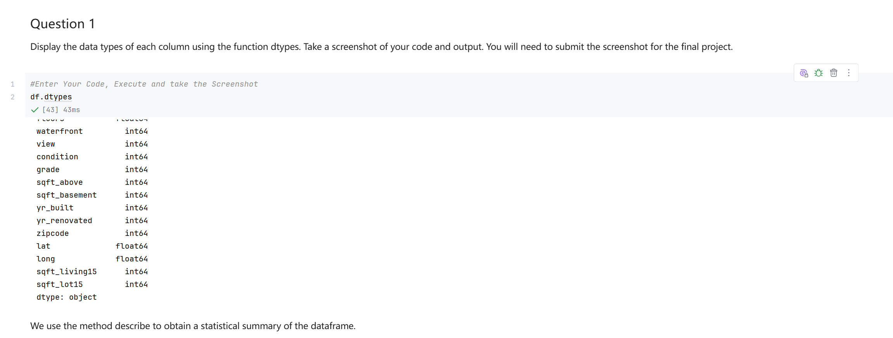
Screenshot file: 03_Q1_df.dtypes.png
(image width 16.4 cm, scale to fit)
df.dtypes lists the type of all 22 columns; price, bedrooms, bathrooms, latitude and longitude are floats, date is text and the remaining attributes are integers.

FinalProject_4. Module 1 Statistical summary of the dataframe
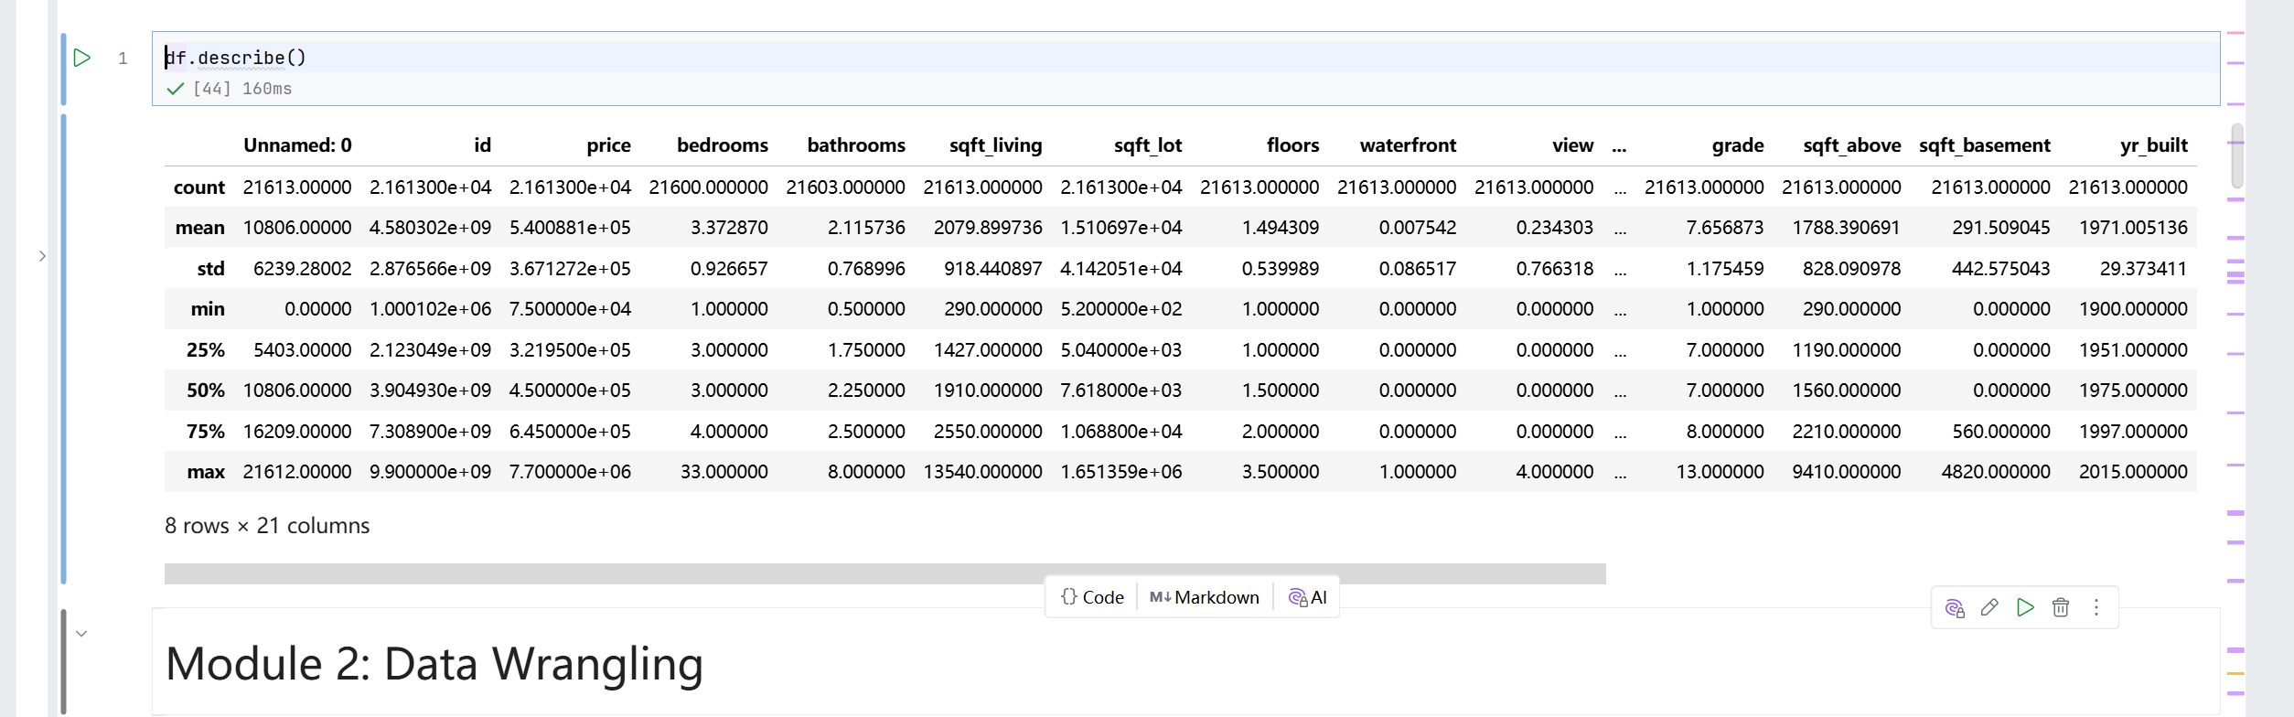
Screenshot file: 04_df.describe.png
(image width 16.4 cm, scale to fit)
df.describe() gives the numeric summary used as a first orientation before cleaning, and shows that bedrooms and bathrooms do not yet cover all 21613 houses.

FinalProject_5. Question 2 Dropping the identifier columns and describing the data
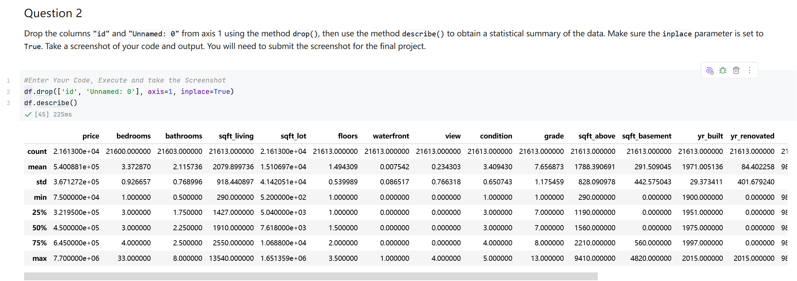
Screenshot file: 05_Q2_df.drop_id_Unnamed0_and_describe.png
(image width 16.4 cm, scale to fit)
df.drop removes id and the unnamed index column from axis 1 with inplace set to True, and the following df.describe() summarises the remaining 20 attributes.

FinalProject_6. Module 2 Filling the missing bedroom and bathroom values
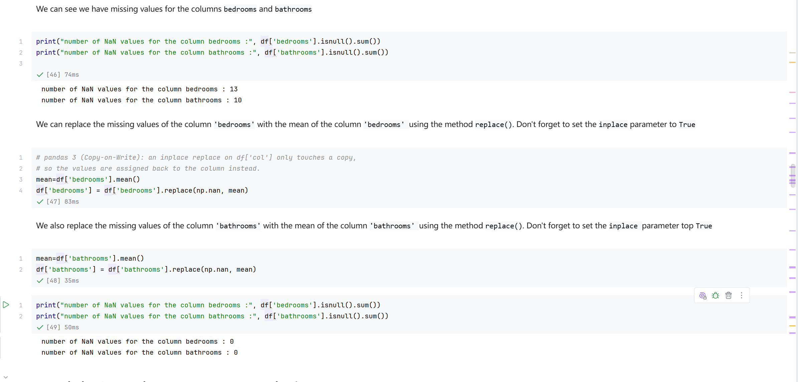
Screenshot file: 06_fill_missing_bedrooms_and_bathrooms.png
(image width 16.4 cm, scale to fit)
The NaN counts for bedrooms and bathrooms are printed and then replaced with the column means, so the two attributes are complete before the regressions are fitted.

FinalProject_7. Question 3 Number of houses by number of floors
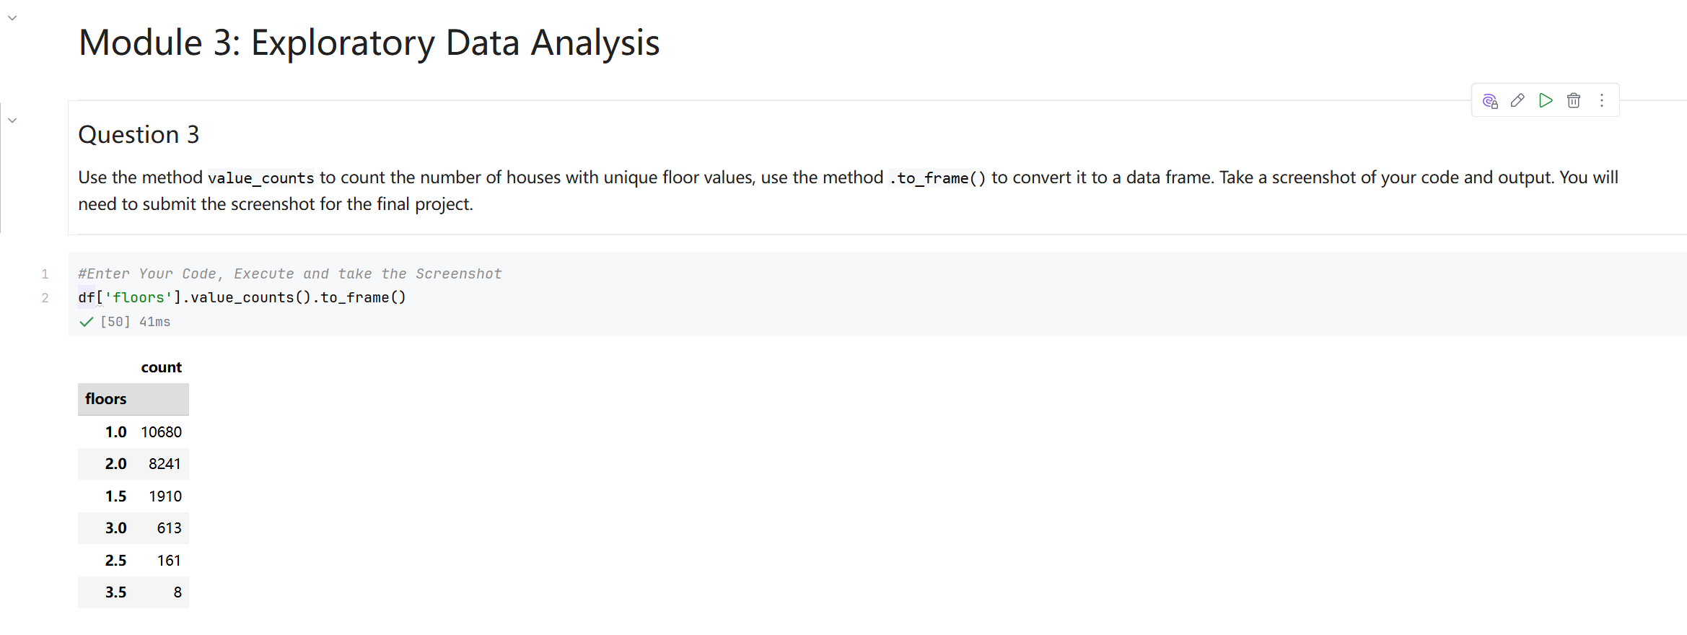
Screenshot file: 07_Q3_df.floors.value_counts_to_frame.png
(image width 16.4 cm, scale to fit)
df['floors'].value_counts().to_frame() counts how many houses have each number of floors; single storey houses dominate with 10680 sales.

FinalProject_8. Question 4 Box plot of price for houses with and without a waterfront view
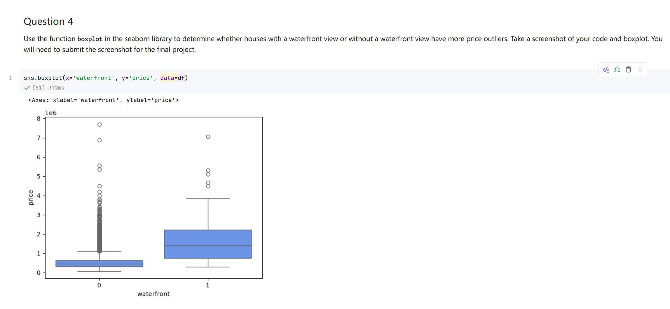
Screenshot file: 08_Q4_boxplot_waterfront_vs_price.png
(image width 16.4 cm, scale to fit)
sns.boxplot for waterfront against price shows that houses with a waterfront view have both a higher median price and more extreme upper outliers, which answers the question.

FinalProject_9. Question 5 Regression plot of price against square footage above ground
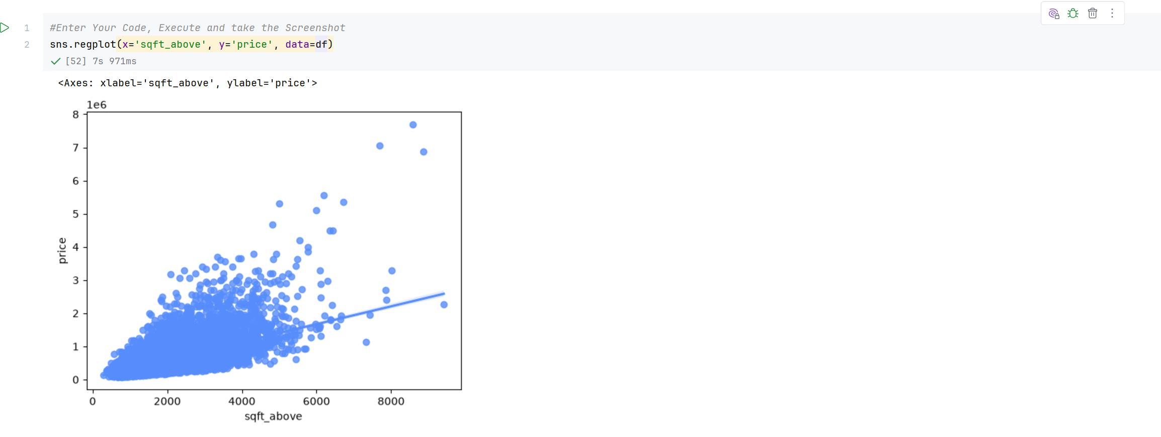
Screenshot file: 09_Q5_regplot_sqft_above_vs_price.png
(image width 16.4 cm, scale to fit)
sns.regplot for sqft_above against price slopes upwards, so the feature is positively correlated with price.

FinalProject_10. Module 3 Ranking the correlations with price
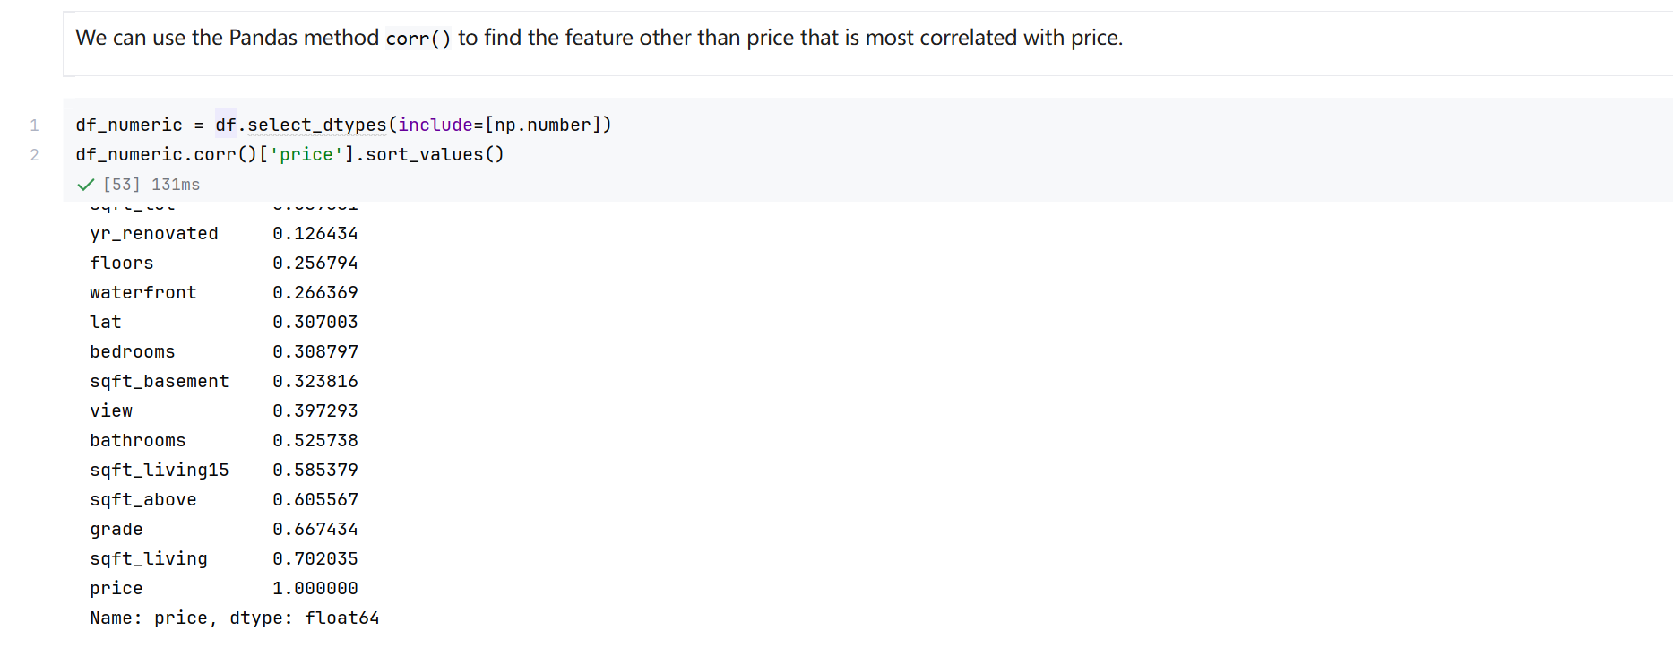
Screenshot file: 10_corr_price_sort_values.png
(image width 16.4 cm, scale to fit)
select_dtypes combined with corr and sort_values ranks every numeric attribute against price; sqft_living, grade and sqft_above come out on top.

FinalProject_11. Question 6 Linear regression with sqft_living and its R squared
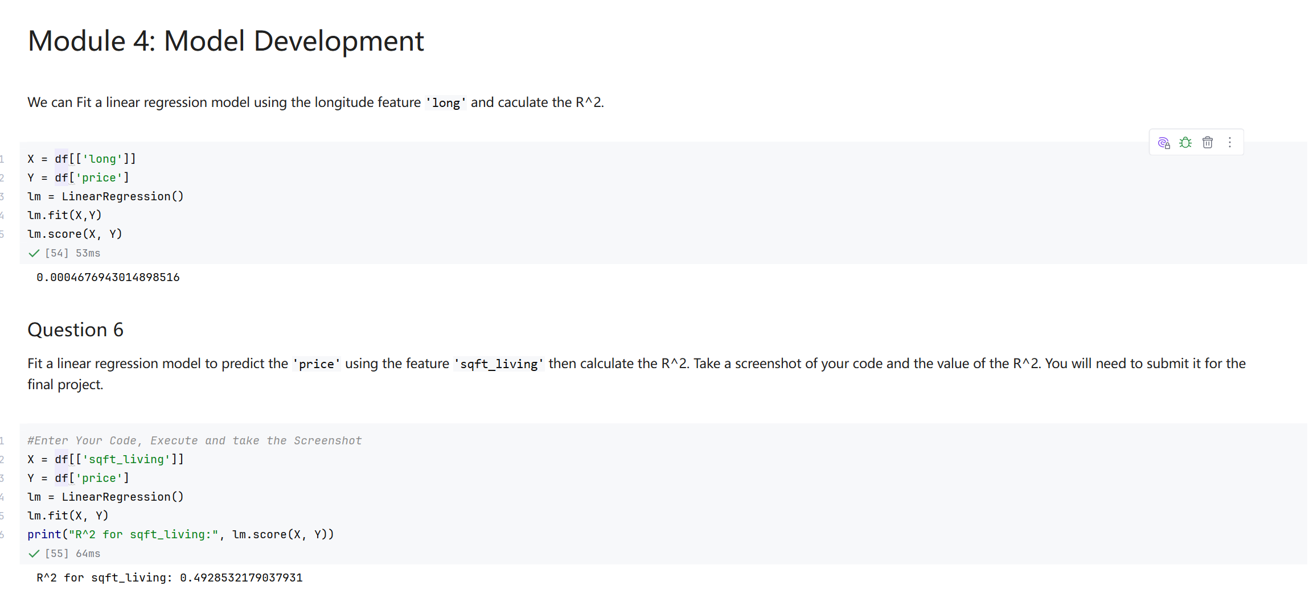
Screenshot file: 11_M4_lm.score&Q6_linear_regression_sqft_living_R2.png
(image width 16.4 cm, scale to fit)
A LinearRegression fitted on the single feature sqft_living reaches an R squared of about 0.493, so floor area alone explains roughly half of the price variation.

FinalProject_12. Question 7 Linear regression with the full feature list and its R squared
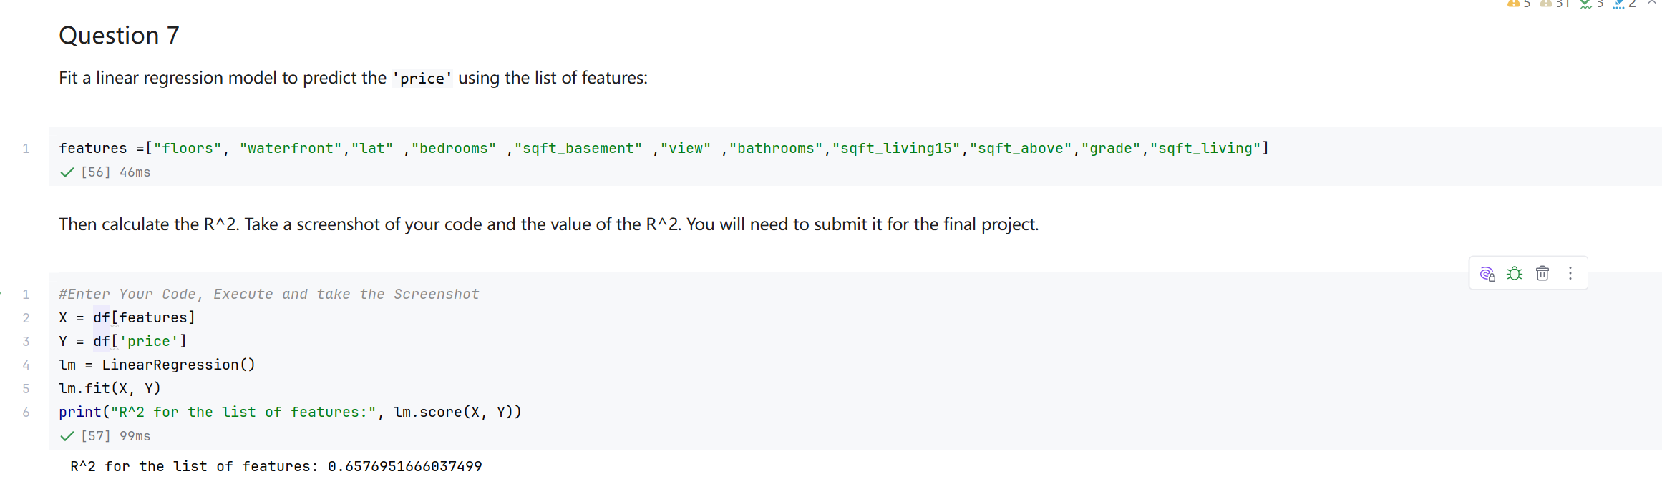
Screenshot file: 12_Q7_linear_regression_feature_list_R2.png
(image width 16.4 cm, scale to fit)
Fitting the model on the eleven features named in the question raises R squared to about 0.658, a clear improvement over the single variable model.

FinalProject_13. Question 8 Pipeline with scaling, polynomial features and linear regression
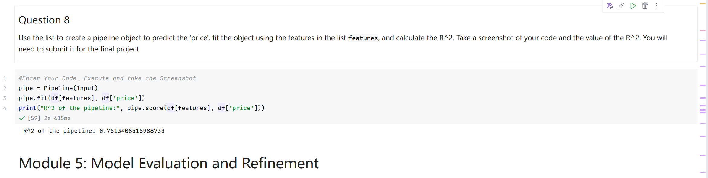
Screenshot file: 13_Q8_Pipeline_fit_score_R2.png
(image width 16.4 cm, scale to fit)
The pipeline applies StandardScaler, PolynomialFeatures and LinearRegression in one object and reaches an R squared of about 0.751.

FinalProject_14. Module 5 Splitting the data into training and testing sets
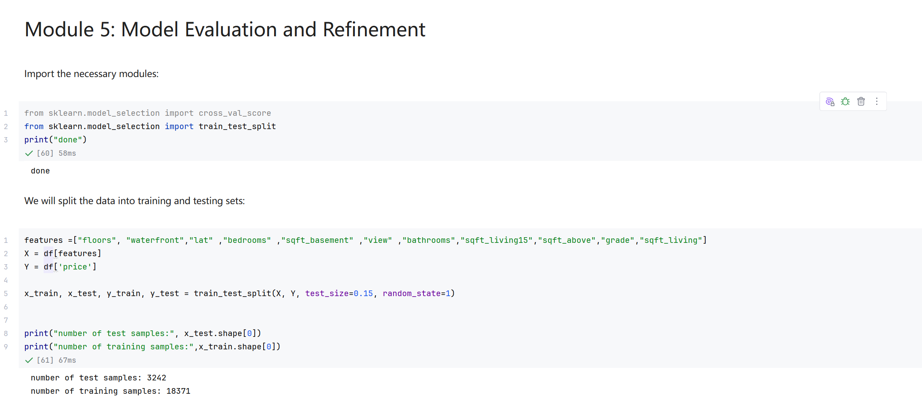
Screenshot file: 14_Module5_train_test_split_test_size0.15.png
(image width 16.4 cm, scale to fit)
train_test_split with test_size 0.15 produces 3242 test records and 18371 training records, the split used by the last two questions.

FinalProject_15. Question 9 Ridge regression with alpha 0.1 and its test R squared
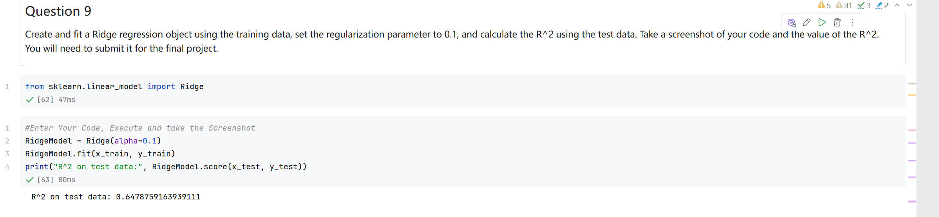
Screenshot file: 15_Q9_Ridge_alpha0.1_test_R2.png
(image width 16.4 cm, scale to fit)
Ridge with regularisation strength 0.1 is fitted on the training set and scores about 0.648 on the test set, lower than the pipeline score because the test records were not seen during training.

FinalProject_16. Question 10 Second order polynomial transform with Ridge regression
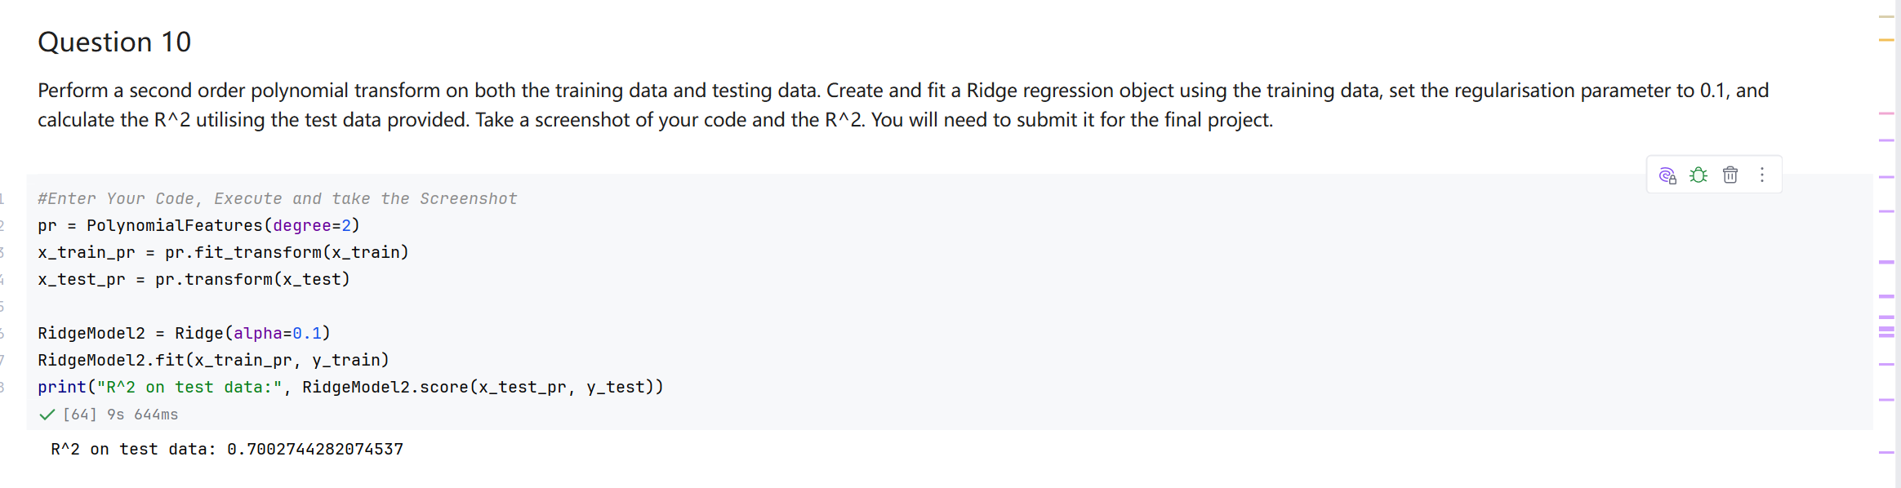
Screenshot file: 16_Q10_PolynomialFeatures_degree2_Ridge_alpha0.1_R2.png
(image width 16.4 cm, scale to fit)
After expanding the features to second order polynomials, Ridge again with alpha 0.1 reaches about 0.700 on the test set, an improvement over the first order Ridge model.

